Guidance on substance misuse referrals

The current Managing Substance Misuse policy states the following:
The Council may test an employee for substance misuse in the following circumstances:
- ‘With cause’, where there is a reasonable suspicion by a manager concerning an employee’s possible inappropriate use of substances which is having an adverse effect on their work or has the potential to put themselves, work colleagues, service users or others at risk in terms of health and safety
- ‘Post incident’ – if it is suspected that substance misuse was a contributory factor to an accident or an incident
- ‘As part of a recovery programme’ – after the initial test, the employee will have two further random tests within a twelve month period. If these tests show no evidence of use/misuse then the employee will continue to be managed as appropriate. If there is evidence of continued use/misuse, then the employee will be managed under the appropriate Council procedure.
The Drug and Alcohol Testing will be undertaken at an OH site. A trained Occupational Health Adviser (OHA) will carry out drug and/or alcohol testing following chain of custody guidelines when collecting a specimen. The drug test will be a Point of Care (POC) instant testing of urine, rather than a blood test. Alcohol testing will be with a breathalyser and if this produces a non-negative outcome, a urine sample will be tested.
It usually takes about 20 minutes to collect urine samples.
Following the testing, the OHA will complete a report for the referring manager advising on a negative/non-negative outcome to the random test, with any additional recommendations. The OHA will complete outcome / interim outcome on the day. The outcome will be issued to the manager within 24 hours.
Non-negative test samples will be forwarded for laboratory GCMS confirmation testing. Turnaround time at Synergy labs is 3-5 days.
Results that are confirmed non-negative are escalated to a Medical Review Officer who will analyse the results and produce a further report advising the results and any action required. The outcome will be issued to the manager within 24 hours.
In order to request testing through OH, this is the process to follow:

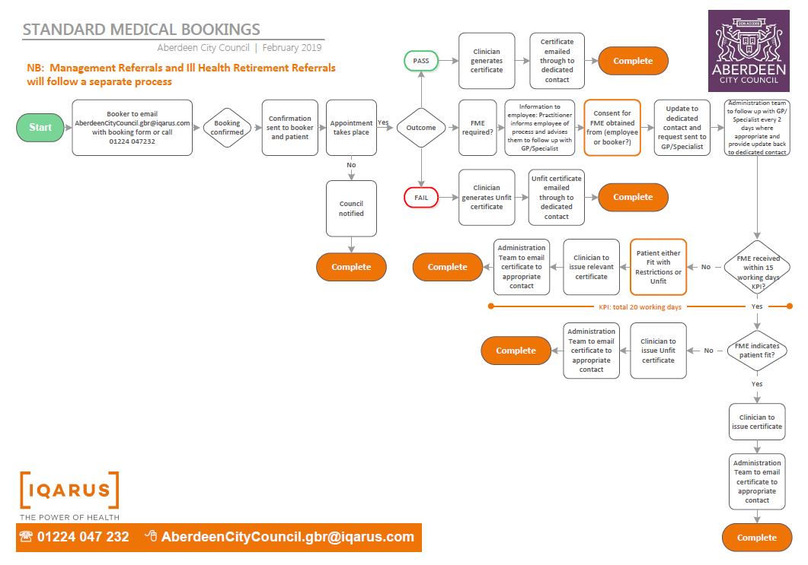

The requesting manager can either request one appointment at a time per person, or more than one e.g. if someone has signed up to treatment agreement for 3 tests over a 3 month period, all 3 tests can be requested at the same time. Appointments as per face to face KPI
The requesting manager will be informed of the appointment date(s) and time(s), and they will then be expected to pass on this information to the employee on the day their assessment is due to take place.

