- The Council recognises the importance of your experience, skills and knowledge as well as the contribution you have made during your time at ACC. We will acknowledge this effort by ensuring your knowledge and experience is not lost on leaving the Council and will, instead, be captured for future benefit.
- As such, the following document outlines the VS/ER knowledge transfer process. You are strongly encouraged to participate in this process so that the key knowledge you hold is captured and retained during your notice period and/if appropriate, once you leave the Council.

1. KNOWLEDGE CAPTURE QUESTIONNAIRE
- On receipt of the formal notice letter you will be invited to complete the knowledge capture questionnaire prior to your departure. You will find the ‘knowledge capture questionnaire’ available within the ‘Your Employment’ section of YourHR as outlined below. A paper copy for those not having access to YourHR can be requested from AskHR on x3939.
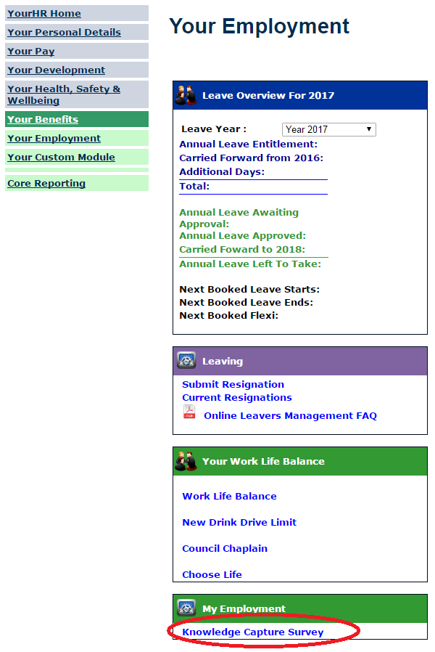
- The questionnaire aims to capture:
  - general information relating to the role
  - the location and availability of relevant documentation and written procedures
  - essential resources and main contacts
  - lessons learned

- Your manager will be notified automatically on your completion of the knowledge capture questionnaire.
2. WORKING FOR THE COUNCIL
- You will also be invited to complete the Working for the Council questionnaire to describe your experiences of working for the Council. This will allow your manager to identify and address any issues so to allow the necessary improvements to be made. A paper copy is available upon request from AskHR on x3939.
- When completing Question 6 of the survey, please select ‘Voluntary Severance/Early Retirement’ as your reason for leaving the Council. You will have an opportunity to expand on the factors that influenced your decision to leave in subsequent sections of the questionnaire.
3. EXIT MEETING AND 4.KNOWLEDGE TRANSFER
- On completion of both the knowledge capture questionnaire and the working for the Council survey please contact your manager to arrange an exit meeting to discuss your responses.
- This will assist in identifying possible ways of capturing key knowledge before you leave Council employment.
5. KEEPING IN TOUCH
- In the interest of maintaining a relationship after you leave Council employment you will be invited to consider the possibility of keeping in contact, on a voluntary basis, with your manager or a suitable colleague, if preferred.
- Staying in touch will allow you to keep up to date with current work and developments which can be useful should there be opportunities to re-engage in particular tasks where your expertise would be useful.

