Quicker Shortlisting
We have updated Talentlink to allow you to view and score applications all from the same screen. This should save you time from checking applications then clicking on the candidate, go to their summary page and then update the feedback forms.
When your applications are ready for shortlisting after the closing date you will go into the Selction/Hiring tab as normal and select In Process from the filter bar to view all your applications. You will now have a Rating section next to each candidates name. If not then please add this column to your view (see new applicant list guide).
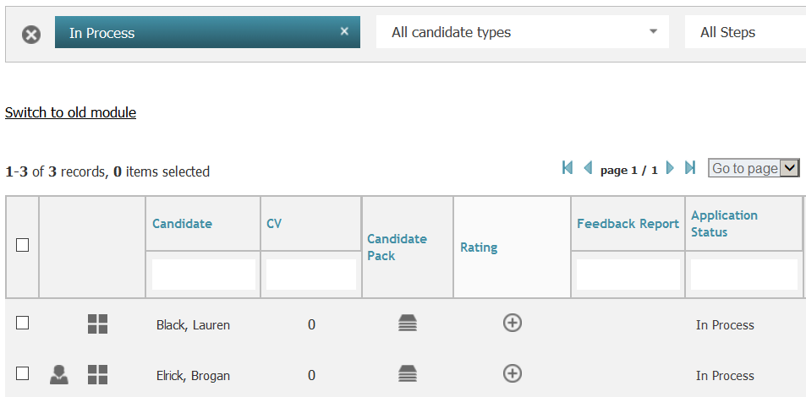
To view an application click on the icon in the candidate pack column next to each persons name and the application will open in a new window. Once you have checked the application you can click on the under the rating section and the below window will open. 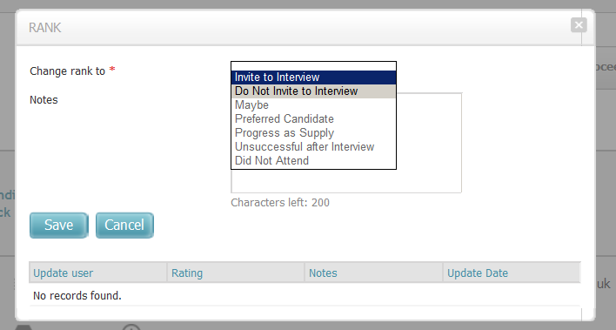

You then can select your decision for that candidate for example ‘Invite to interview’ or ‘Do not invite to interview’. There is an optional box for notes if you wish to use them (might be helpful for your maybe candidates to come back to later)
When you have made your decision click Save and your main screen will then be updated to the below as an example;
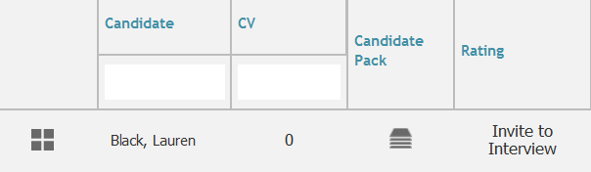

You repeat this task for each of the applicants for your post.
When this has been completed, please send your Interview details form to the HR Support team who will make the necessary arrangements for your interviews.
*When interviews are completed you can also use this rating section to update your decision after interview. To do this you would click on your decision prior to interview, for example ‘Invite to interview’. The same pop up will appear and you would then simply change your decision to reflect whether the candidate was the preferred candidate for the position, did not attend, or was unsuccessful.
We hope this new way to shortlist will save you time and make it an easier and quicker experience. However, if you still wish to shortlist the original way then the function is still available for you to use.

