WILLIAM BRIDGES – TRANSITION THEORY & THE MARATHON EFFECT
This is a theory by William Bridges is called Transition theory and it seeks to explain how people transition from where they are now (the current state) to where they end up (the future state).
According to Bridges, a transition has three phases
- It starts with an ending (Sometimes you have to let go / stop doing in order to move onto something new)
- Once you let go, you enter a neutral zone (this is where you are neither the old state or new state yet, he describes it as a state of limbo)
- There is then a conscious choice to step out of the neutral zone and into the final phase which is the new beginnings.
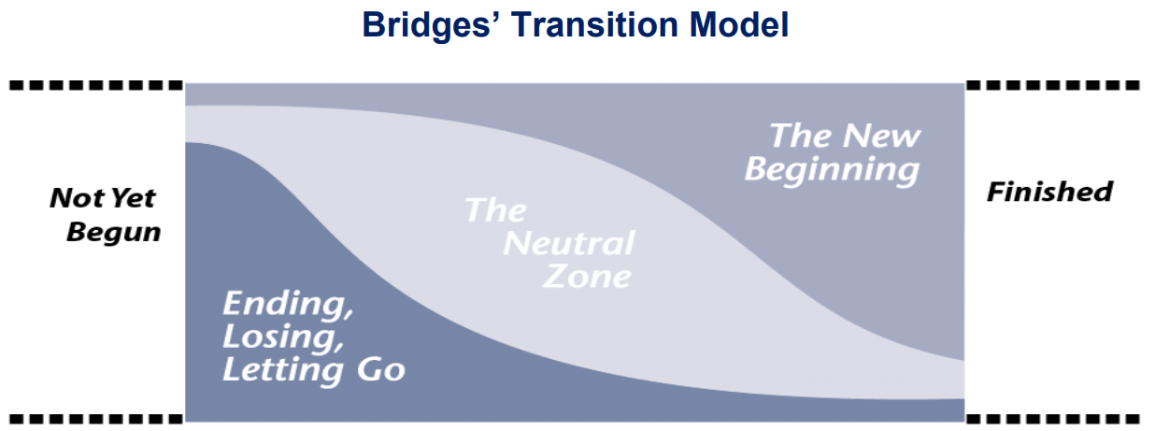
Bridges promotes the idea that instead of describing ‘the gap’ between the old and the new as ‘change’ which is external; we talk about it as a transition which is internal move to adapt to the external changes.
Change is…. | In contract – Transition is…
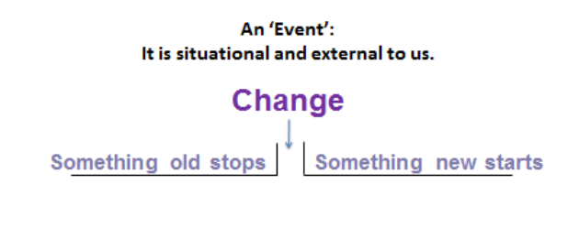 | 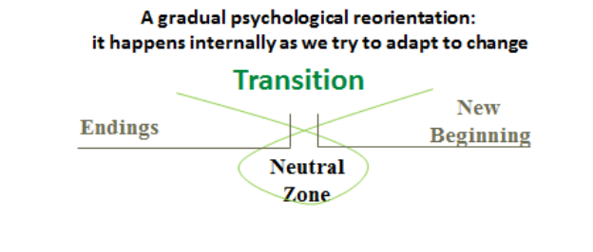
The significance of using this model is that it focuses on transition, not change. The difference between these is subtle but important. Change is something that happens to people, even if they don't agree with it. Transition, on the other hand, is internal: it's what happens in people's minds as they go through change. Change can happen very quickly, while transition usually occurs more slowly. This is significant in dealing with change as it presents the idea that supporting people going through change is equally as important as managing the processes itself.
Bridges says that people will go through each stage at their own pace. For example, those who are comfortable with the change will likely move ahead to stage three quickly, while others will linger at stages one or two. Don't get impatient or try to push people through to stage three; instead, do what you can to guide them positively and sensitively through the change process.
An understanding of the main 3 phases and how that might affect individuals and teams, allows a manager to plan their change and communications to take account of people involved, therefore reducing negative responses. Below is an illustration of each of the three phases and some of the key features of each one.
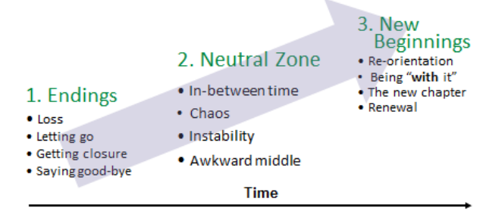
Whilst this illustration shows a linear timeline is it important to realise that the journey may not be a smooth transition and that people may flex between the phases depending on circumstances. Here’s a closer look of what happens at each stage. Remember transitioning isn’t a linear process.
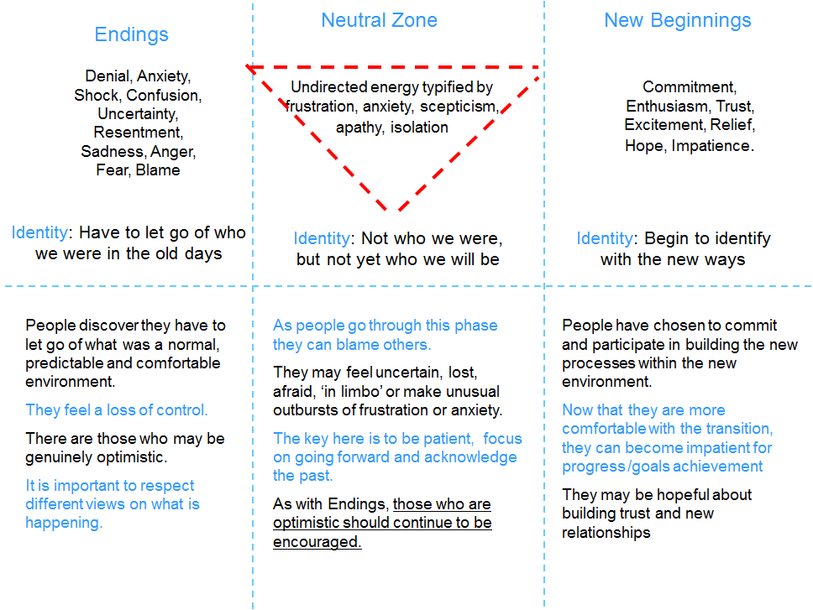
Let's examine each phase in greater detail:
Phase 1: Ending, Losing, and Letting Go
People enter this initial stage of transition when you first present them with change. This stage is often marked with resistance and emotional upheaval, because people are being forced to let go of something that they are comfortable with.
At this stage, people may experience these emotions:

• Fear
• Denial
• Anger
• Sadness
• Disorientation
• Frustration
• Uncertainty
• A sense of loss

People have to accept that something is ending before they can begin to accept the new idea. If you don't acknowledge the emotions that people are going through, you'll likely encounter resistance throughout the entire change process.
This is an illustration of Bridges theory mapped alongside Elizabeth Kubler-Ross’ change curve.
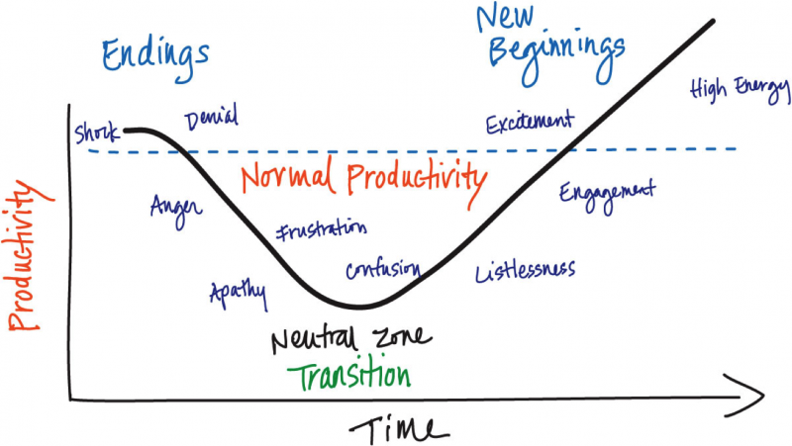
This diagram shows some of the key emotions people affected by change might experience. Spotting the emotional state of individuals can help you identify where they are on the transition journey to allow you to know how best to offer support.
Guiding People through Stage One
It's important to accept people's resistance, and understand their emotions. Allow them time to accept the change and let go, and try to get everyone to talk about what they're feeling. In these conversations, make sure that you listen empathically and communicate openly about what's going to happen.
Emphasise how people will be able to apply their skills, experience, and knowledge once you've implemented the change. Explain how you'll give them what they need (for instance, training and resources) to work effectively in the new environment.
People often fear what they don't understand, so the more you can educate them about a positive future, and communicate how their knowledge and skills are an essential part of getting there, the likelier they are to move on to the next stage.
Phase 2: The Neutral Zone
In this stage, people affected by the change are often confused, uncertain, and impatient. Depending on how well you're managing the change, they may also experience a higher workload as they get used to new systems and new ways of working.
Think of this phase as the bridge between the old and the new; in some ways, people will still be attached to the old, while they are also trying to adapt to the new.
Here, people might experience:
• Resentment towards the change initiative.
• Low morale and low productivity.
• Anxiety about their role, status or identity.
• Scepticism about the change initiative.

Despite these, this stage can also be one of great creativity, innovation, and renewal. This is a great time to encourage people to try new ways of thinking or working.
Guiding People through Stage Two
Your guidance is incredibly important as people go through this neutral period. This can be an uncomfortable time, because it can seem unproductive, and it can seem that little progress is being made.
Because people might feel a bit lost, provide them with a solid sense of direction. Remind them of team goals, and encourage them to talk about what they're feeling.
Meet with your people frequently to give feedback on how they're performing, especially with regard to change. It's also important to set short-term goals during this stage, so that people can experience some quick wins; this will help to improve motivation as well as giving everyone a positive perception of the change effort.
Also, do what you can to boost morale and continue to remind people of how they can contribute to the success of the change. If required, you may also want to help people manage their workloads, either by deprioritising some types of work, or by bringing in extra resources.
Phase 3: The New Beginning
The last transition stage is a time of acceptance and energy. People have begun to embrace the change initiative. They're building the skills they need to work successfully in the new way, and they're starting to see early wins from their efforts.
At this stage, people are likely to experience:
• High energy
• Openness to learning
• Renewed commitment to the group or their role

Guiding People through Stage Three
As people begin to adopt the change, it's essential that you help them sustain it. Use techniques like Management by Objectives to link people's personal goals to the long-term objectives of the organisation, and regularly highlight stories of success brought about by the change.
Take time to celebrate the change you've all gone through, and reward your team for all their hard work. However, don't become too complacent – remember that not everyone will reach this stage at the same time, and also remember that people can slip back to previous stages if they think that the change isn't working.
This video explains the three steps more closely and what a manager can do to manage people through the transitions.
Now you have a better understanding of the main phases
This presentation outlines more ideas of what you as a leader of your teams can do.

Using Bridges theory to understand how communication can breakdown.
Below is an illustration of what Bridges called ‘the Marathon Effect’. It shows a map of the three phases of Bridges theory (Endings, Neutral and Beginnings) mapped out on a timeline for different levels of managers as they are introduced to a change and start to communicate about it.
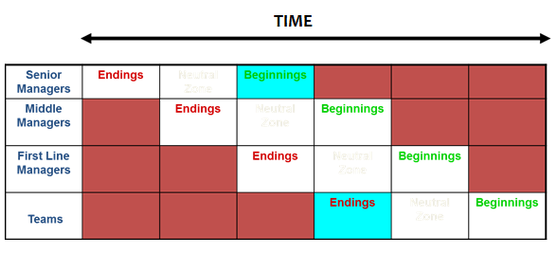
How it works in practice:
The senior leaders may initiate a transformation that results in change. Their knowledge and understanding puts them at the front of the timeline and their journey through the transition phases starts first.
From that first position, the senior leaders begin communicating to various stakeholders (including staff) about the change initiative. They convey its’ importance, its’ benefits and cast a (hopefully inspiring) vision for the future.
While the senior leaders continue through their own journey and communicate, the middle managers start their own transition journey and start cascading communication to others (First line managers) and so the ripple of the marathon effect works. From the illustration, you can appreciate that the transition journey for senior leaders might be fully complete before individuals in teams even start their own transition.
In practice often managers fail to take account of the timeline differences and can get tired of communicating over and over and over. It can be a source of frustration that others in the organisation are not bought into the new beginnings and this can lead to a breakdown in communication which leads to disengagement at both levels.
A manager who understands this process and appreciates that many of the organisation still have not yet heard the important messages at all is more equipped to offer the on-going leadership and direction needed to motivate and engage their teams.
To plan for the marathon effect a manager has 3 options:
- Stop communicating altogether
- Enlist others to help cascade their messages (risky in that the messages may become diluted, but potentially effective, and often essential in large organisations)
- Commit to leading the change all the way through. Communicating to consistently reinforcing the change messages until all levels of the organisation have completed the transition.
Some change initiatives are SO big and SO complex they require many leaders to cast the vision and communicate endlessly. It is key is that as a leader you resist the temptation to stop communicating because it feels like they are repeating the same messages too often, until you are sure that all pockets of the organisation have had the opportunity to see, hear and feel your personal inspiration for the new future.

