Speed of Trust

“Trust doesn’t just happen. It is a product of purposeful focus, action and behavior” Covey
Team Leaders’ Toolkit

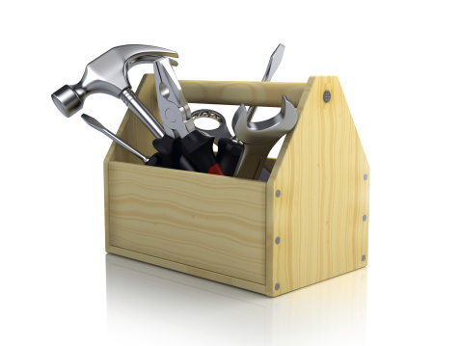
In his book, The Speed of Trust, Stephen M.R Covey says that trust is “the one thing that changes everything”

Trust doesn’t just happen. It is a product of purposeful focus, action and behaviour.

This is a 60 minute exercise that facilitates a series of team conversations around trust. The goal is to create the desire and commitment to build trust within the team and at the same time highlight any areas which are preventing this from happening. You can choose to run all exercises consecutively in one go or phase them over a period of time.

This toolkit is designed to provide a couple of example exercises which complement the Speed of Trust Leader Conversation Kit. You can gain access to the kit by contacting the Organisational Development team.

Facilitator Notes

The purpose of the exercises is to facilitate an open and honest conversation around what trust is and the current level of trust in the team. As a facilitator you may find the following points useful:

- Give delegates advance warning about the purpose of the session and what they can expect
- Ask open questions as much as possible to tease out opinions
- If there are areas of low trust try and find solutions as a team about how to address these
- Allow for emotions to surface – don’t be tempted to shut them down
- Reference the organisational behaviours of respect, professionalism, communication and customer focus to keep conversations constructive.
- Give the team accountability for building and maintaining trust – it is something you all own and have responsibility for

You may find it beneficial to have access to the following materials:
- Flipchart, paper and pens
- Post-it’s
- Blue tack
- Trust Conversation Kit (access via Organisational Development Team)

Activity 1 – What Is Trust?

To introduce the concept of Trust ask the team to individually spend a few minutes thinking of a low-trust relationship they have now or have had in the past.

Now think of a high trust relationship.

How are they different? How do they affect the ability to make decisions? Produce quality? Generate creativity? Enjoy the work?

Ask group to flip chart key differences on two different pieces of flip chart paper so that they begin to build up a profile. Individuals can move between both at will.

Discuss:
- What are the key differences between high trust and low trust relationships?
- What is the impact of both on individuals, the team, the organisation and our customers?

Activity 2 – Character and Competence

Stephen Covey says that trust is not absolute. We trust a person based on their credibility, and credibility is based on two parts: character and competence.

Character is who I am and how I live my internal values. It is my integrity and intent.

Competence is what I can do. It is my capabilities and also the results I have achieved in the past.

Discuss:
- Is it possible to trust someone’s character but not their competence? Give an example.
- Is it possible to trust someone’s competence but not their character? Give an example.

Open the deck of Trust Action Cards and find the 4 Cores of Credibility which are labelled Integrity, Intent, Capabilities and Results.

Discuss:
- Which of the 4 Cores of Credibility is our team’s greatest strength?
- Which of the 4 Cores will require the most attention and improvement by our team?

Activity 3 – What does Trust Look like in our team?

It is not enough to read about trust, or to think about it, or talk about it. To build trust in a team specific and purposeful action must be taken.

For the next part of the dialogue, the 13 Behaviours of High Trust will be discussed.

Create three columns or piles labelled ‘does not demonstrate’, ‘sometimes demonstrates’ and ‘exceeds’. Read through each of the 13 Behaviours and place the cards into the relevant column or pile.

Discuss:
- Which behaviours are we poor at as a team and why?
- Which behaviours do we exceed at and why?
- Which of the behaviours in the ‘does not’ or ‘sometimes demonstrate’ column do we need to work on as a priority?
- What actions do we need to put in place to improve these behaviours?

Activity 4 – Team check in

What level of trust do you think exists in the team at the moment?

Ask individuals to position themselves in the room along a scale of 1 to 10 – one being the lowest level of trust and 10 being high trust.

Ask people to clarify their scores.

Discuss:
- Why are people standing at that point on the scale?
- What enables and inhibits trust in the team currently?
- What do we need to do to address this?

Activity 5 – Areas of Improvement

What actions do we need to commit to in order to build trust in the team?

Ask all team members to write down one individual commitment.

Discuss:
- Each person’s commitment
- How will we know if we have been successful?
- How are we going to maintain this?

