Embedding the Organisational Behaviours

“I don’t shine if you don’t shine” The Killers
Team Leaders’ Toolkit

All managers are ambitious for their teams. They want to see them deliver what’s expected, to do well, to excel.

Some schools of thought base success on systems thinking – if the systems are right success will follow. Yet we don’t always have control over systems, so this type of thinking can leave us feeling helpless in the face of the organisational ‘machine’.

Alternative schools give the power back to managers. In his book ‘From Good to Great’ Jim Collins focuses on the importance of people – having the right leaders, working to the right behaviours and a slow, relentless focus on improvement rather than big bangs and miracles. If this view is correct we’re no longer victims – we can be the cause not the effect.

The organisational behaviours agreed under the Performance Review and Development scheme provide the opportunity to set the bar in terms of expectations. At the same time they provide a standard to work to and give criteria for deciding ‘what’s the intelligent thing to do’ in a situation where there are no rules or precedents to follow.

However, if they are to be more than words on
paper, they need to be introduced carefully, embedded, talked about and lived. And – as Jim Collins says – this is best done not with a bang but with steady, relentless repetition till they become part of the fabric. This will take time but the return on investment should be significant in bringing about a culture change in the organisation.

This toolkit provides one or two suggestions as to how you, as managers, might:

- introduce the behaviours to your teams;
- stimulate discussion round them;
- promote change and continuous improvement based on the behaviours.

At the same time it prompts you to think about the importance of your role in ‘being what you want to see’ and in ensuring you yourself are living up to the management standards set.
The following activities can be used with individuals, in teams, in sections, in services. You can use some - or all - of the activities and adapt them to suit your circumstances. They will be added to over time.

Activity 1 – Introducing the Behaviours

Either at a team meeting or in 1-2-1s, introduce each core behaviour along with its definition and why it’s important:

Communication  Definition:  Communicates in a way which is clear, open, honest and constructive; shares, listens and responds to information, options, ideas and instructions. | Why it’s important: good communication ensures everyone understands what the organisation is trying to achieve; it leads to fewer misunderstandings, better decision making, greater job satisfaction, higher morale and better working relationships.
Customer Focus  Definition:  Recognises customer service is part of everyone’s job; takes into account customer needs and expectations; strives to meet expectations where possible, manages expectations where this is not possible; is proactive in improving the service. | Why it’s important: because getting it right first time saves time and money and improves reputation; because customers are a ready and valuable form of feedback leading to service improvement; because without customers we are without jobs.
Professionalism  Definition:  Maintains the standards expected by the service and the organisation at all times; remembers that they are representing the Council. | Why it’s important: because professionalism leads to high standards and high quality work; because employees who have high standards of professionalism are perceived as being reliable and credible; because professionalism leads to a better working environment for all.
Respect  Definition:  Behaves in a way that demonstrates respect for people, property and policy. | Why it’s important: because respect helps people to work more effectively together; because respect encourages communication and collaboration.

Discuss:
- On a scale of 1-10 how important each one is to the team
- Which is a natural strength for the team
- Which will need most effort to apply consistently
- Which is most critical to the success of the team
- What do we, as a team, need to do now.

Activity 2 – What it means for us

Look at the job profiles for each team member:

Discuss:
- What the indicators mean in the context of the work the team does
- What customers will expect against each behaviour/ indicator
- What the team expect of each other against each behaviour/ indicator
- What differences, if any, there will need to be in the way we work
- What do we, as a team, need to do now.
Activity 3 – Looks like/ doesn’t look like

Look at the behaviours and indicators for each job in the team:

- Draw up a table with 3 columns
- Put the current indicators in the middle column
- Based on the current indicators:
  - Discuss and agree what ‘exceeding’ in the behaviour would look like in that particular job; record in the right hand column
  - Discuss and agree what ‘not meeting’ that behaviour would look like; record in the left hand column
- Use the table as basis for standard setting in the future

Activity 3 – Self evaluation

- Use Self Assessment Tool 3: How ready are you? On a scale of 1-10 rate how far you, as a manager, meet the expectations set out. Note any actions you need to take.
- Ask your team to create similar tools based on their job role and rate themselves.
- Depending on preference, outcomes can be kept for each individual’s own reference and development or they can be shared with yourself as part of your 1-2-1s.

Activity 4 – Core conversations

To keep the conversation going, every 8 weeks or so, pose a question to the team based on one of the core behaviours (or take it in turns within your team to pose the questions). For example, under customer focus you could ask ‘how can we raise the bar in terms of customer service in this team’ – discuss this at team meetings or have a manual or virtual means for people to record their thoughts.

For example you could have people add their thoughts to a flipchart or use post-its on a notice board; or open a virtual flipchart on a shared drive or on yammer; or contact Employee Development to ask how to use Employee Voice for in service ideas sessions. Make sure you respond to any suggestions made and publish any actions taken.
Activity 5 – Temperature Checks

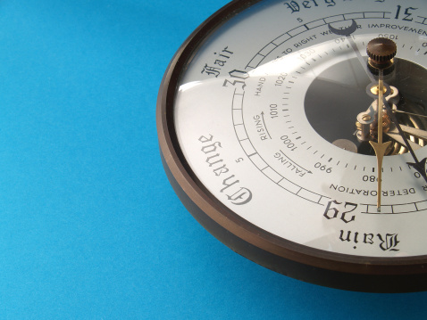

The PR&D process provides an annual temperature check on how well you’re meeting the expected standards – particularly for managers who are using the 360 review process. You could however carry out periodic temperature checks within your team or service to check how things are going. For example you could take the outcomes from the earlier activities and review where you are 6 months down the line. This could be anything from a simple internal straw poll to a customer survey or a surveymonkey evaluation within the service as a whole.

