Access to Work - Resource Pack
Access to Work is a government run specialist disability programme which provides practical advice and support to disabled people and their employers to overcome work related obstacles resulting from their disability. It is the legal responsibility of employers under the Equality Act to provide reasonable adjustments to allow disabled staff to do their work. The Access to Work (AtW) programme is intended to provide funding towards equipment and support that would be above and beyond what is reasonable for an employer to supply.
In addition to supporting disabled people who are starting or already in work or self-employment, over recent months the AtW scheme has been opened up to support more young disabled people on traineeships, supported internships and work academies. It is also planned to open up the scheme further to disabled people who find their own work trials and work placements with an employer, where there is a 'realistic prospect' of a job at the end of it.
We hope you find this resource pack useful.

Introduction
- An Introduction to Access to Work - Presentation (with notes)
- Access to Work leaflet

Factsheets
- Access to Work - Guide for Employees
- Access to Work - Guide for Managers

Case Studies
- Case Study - Danny
- Case Study - David
- Case Study - Emily
- Case Study - Janet
- Case Study - Karan
- Case Study - Nicola
- Case Study - Ryan

FAQs
- Frequently Asked Questions on using Access to Work

Mental Health Support Service

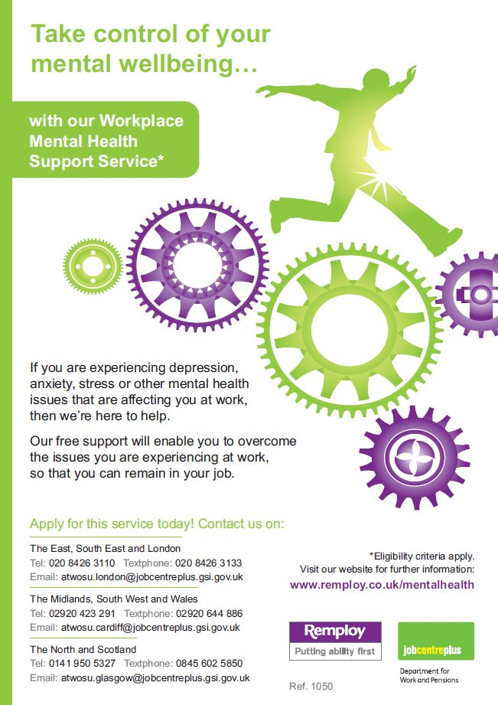
In addition, through Access to Work, specialised support is available to individuals with a mental health condition, who are absent from work or finding work difficult and includes:
- Work focused mental health support, tailored to the individual
- Assessment of an individual's needs to identify coping strategies
- A personalised support plan, detailing the steps needed to remain in, or return to, work
- Suggestions for reasonable adjustments in the workplace, or in working practices
- Advice and guidance to enable employers to fully understand mental health and how they can support employees who have a mental health condition
This is a confidential and impartial service and consultants are fully trained professionals with specialist expertise in mental health and its impact on the workplace.
- Mental Health Support Service Leaflet
- Mental Health Support Service Poster

Contact Details
Access to Work - Glasgow
atwosu.glasgow@dwp.gsi.gov.uk
Telephone: 0141 950 5327
Textphone: 0845 602 5850
Fax: 0141 950 5265

Other Useful Links
- https://www.gov.uk/government/publications/the-disability-confident-campaign
- https://www.gov.uk/government/publications/employing-disabled-people-and-people-with-health-conditions/employing-disabled-people-and-people-with-health-conditions
- https://www.gov.uk/access-to-work
Please be aware that you may not be able to visit these sites unless you have been setup with access or during certain times. Aberdeen City Council is not responsible for the content of external websites.

Other Information

Policies related to Access to Work
- Access to Work Scheme: Guidance for Managers
- Diversity and Equality Policy
Disability in the Workplace Guidance

